Sportscam MiniDVR Manual
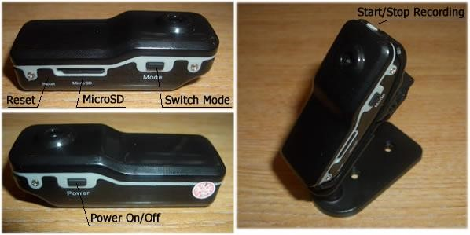

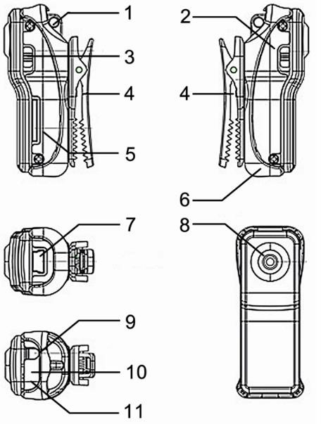
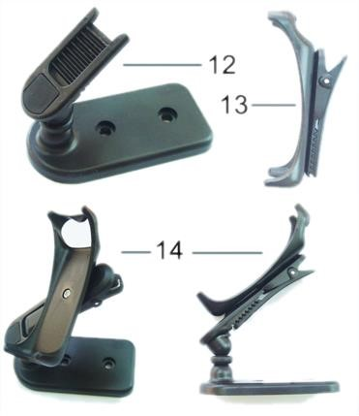
Key:

- Lanyard Hole
- Power
- Mode
- Clip
- Micro SD
- Camera Holder
- MiniUSB Connection
- Camera Lens
- Power On/Off
- Status Indicator
- Microphone
- Clip Mount
- Clip
- Clip & Mount Connected

Introduction
This mini DV recorder is a High Definition video recorder with simple operation and sound control. Its elegant design and small size make it easy to carry and can be an essential utility in business, education, security, media, justice, tourism, healthcare and entertainment.

Operating Instructions

Charging
The built in lithium rechargeable battery is partly charged so will require a full charge before first use. Connect the MiniUSB cable to the device and plug into a spare USB port on a computer that is switched on. When on charge the red light comes on solid whilst the blue light flashes slowly. When the blue light stops flashing the unit is fully charged.

Power on to Video Recording
Press power button to turn the device on. The blue indicator will come on to indicate the device is on and in standby mode. Press the Stop/Record button once to begin recording. The red led now flashes to indicate the device is recording. Press the Stop/Record button again to stop recording video and the red light will stop flashing and return to a solid blue.

Notice:
a) Please make sure that a MicroSD card has been inserted. If no card is inserted when the device is turned on, the red light comes on solid and the blue light flashes continually. b) The maximum capacity of the MicroSD card is 16GB
- When you have finished recording and press stop, please remember the device will take a few moments to save the file. Avoid pressing the Stop/Record button continuously to avoid getting unsmooth and/or incomplete files.
- When making a video, please keep focus on the object from a distance of at least 50cm under sufficient illumination. This will ensure bright clear and stable images are recorded.

Sound Control Video
To enable sound control mode, press the power button to turn the device on. The blue LED will come on solid to indicate standby mode. Now press the “Mode” button. The blue LED remains on whilst the red led begins to flash quickly. This indicates the camera is now in sound control mode. If a noise above 60 decibels is detected then video recording is started and the red led will flash slowly. If the sound level drops below 60 decibels for longer than 2 minutes, recording will stop and the red light will return to rapid flashing to indicate the device is back in standby mode and waiting for more sound.

Setting The Time for the OSD
When the item is turned on, it writes a file to the inserted memory card called “time.txt”. You can edit this file to match the current time and date and then save. The next time the item is turned on, the internal time and date will be changed to match the “time.txt” file and this time & date will be shown embedded onto the video.

Power Off
Under video mode or standby mode, press power button down for 3 seconds until the indicator light goes out. The device is now powered down.

Auto Power Off
The device will auto power down under the following circumstances:
- If the device runs out of power whilst shooting video the file will be saved and the device will power down.
- When there is not enough space on the MicroSD the file will be saved automatically and the device will power down.
- When in standby mode, if the device is idle for 45 seconds it will auto power down.

Connecting To Computer
Connect the included MiniUSB cable to the device and then connect to a spare USB port on a computer that is switched on. Under any version of Windows from XP service pack 2 and onwards, the required ‘Mass Storage’ drivers are automatically installed. A new drive will appear under “My Computer” – this is the MicroSD card installed in the device. Please Note: (a) If the MicroSD card is not showing after ~30 seconds, disconnect and then reconnect the device. (b) It is recommended that you copy the files from the MicroSD card to your computer before trying to open them.

Device Details

Feature | Details
Video Format | AVI
Video Encoding | M-JPEG
Video Resolution | 720*480 VGA
Video Frame Rate | 30FPS ± 1fps
Media Playing Software | VLC Media Player Recommended
Image Ratio | 4:3
Supported OS’s | Windows XP/Vista/Win7 32bit
Charging Voltage | DC-5V
Interface Type | MiniUSB 5 pin
Storage Support | MicroSD memory card
Battery Type | High Capacity lithium polymer

